BOOTH SETUP AND EQUIPMENT
☐ | Overhead Protection  All equipment, food, condiments and single service items are covered with overhead protection
☐ | Hand-Washing Station Equipment/Supplies  - at least one hand-washing station with hand soap, paper towels, and a waste receptacle  - a plumbed sink or a five gallon catch bucket or similar  - Posted sign that notifies food workers to wash their hands for at least 20 seconds
☐ | Public Access to Food Preparation and Cooking Areas  Barrier(s) in place to ensure that the public is not able to access your food preparation areas and cooking areas
☐ | Storage of Personal Items  Personal clothing and belongings are stored in a designated place away from your food operations
☐ | Toxic Materials  Items are stored in their original container, in their right area, and properly labeled
☐ | Ware-Washing Station  - 3 separate basins for washing, rinsing, and sanitizing  - designated area to air-dry dishes and utensils  - extra utensils to reduce the need for washing

TEMPERATURE CONTROL
☐ | Temperature Measuring Device  Use a food thermometer to periodically check the internal temperature of your foods
☐ | Hot Holding  - Hot high risk foods are hot held at 135°F or above  - Hot holding equipment capable of maintaining high risk foods at 135°F or above at all times including during transport
☐ | Cold Holding  - Cold high-risk foods are cold held at 41°F or less  - Cold holding equipment capable of maintaining high risk foods at 41°F or below at all times including during transport
☐ | Cooling  All food workers understand there will be no cooling of foods
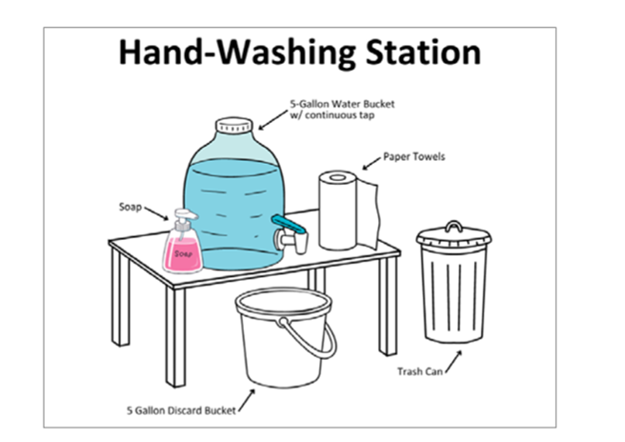

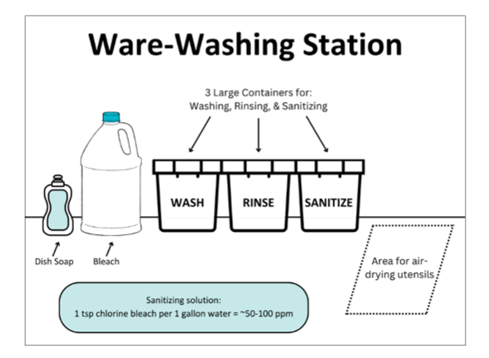

FOOD SERVICE WORKERS
☐ | Food Worker Card  All food workers have an onsite copy of their valid food worker card issued by a Tribe, Indian Health Service, or [INSERT STATE(S)]
☐ | Hygiene  All food worker’s hair is either completely pulled back or worn under a hat or hair net

WATER SUPPLY AND DISPOSAL
☐ | Water Source  All water used in the establishment is potable and from an approved public source
☐ | Food Grade Hoses  Hoses used to transport potable water are food grade
☐ | Wastewater Disposal  All food workers know the approved location for dumping wastewater and that wastewater may not be dumped in storm drains, toilets, or on the ground

BOOTH SUPPLIES
☐ | Sanitizing Solution and Wiping Cloths  Bleach is most common
☐ | Test Strips for Sanitizer Solution
☐ | Food Thermometer  For measuring internal temperature
☐ | Gloves or Other Barriers  To prevent bare-hand contact with ready to eat foods
☐ | Ice  Ice is from an approved source or commercially made and not from home

