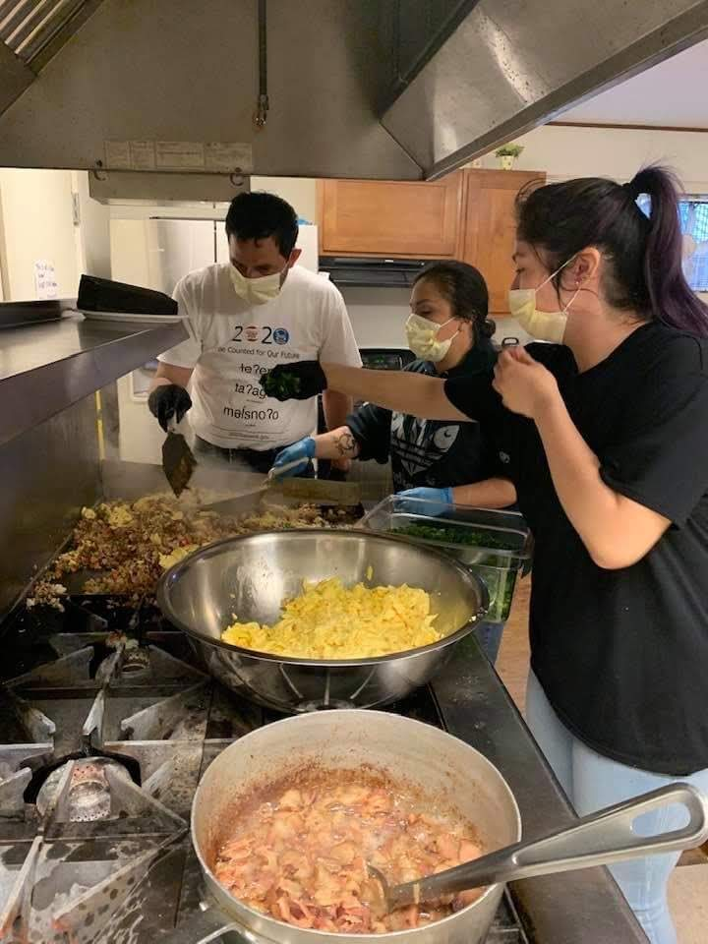

AMERICAN INDIAN HEALTH COMMISSION

MODEL TRIBAL TEMPORARY FOOD ESTBALISHMENT GUIDE

Developed by the American Indian Health Commission - June 24, 2025
Funded by Washington State Foundational Public Health Services


AMERICAN INDIAN HEALTH COMMISSION

HOW TO USE THIS MODEL GUIDE
The American Indian Health Commission (AIHC) developed this Model Tribal Temporary Food Establishment Guide for use by Tribes at single events such as a canoe journey, pow wows, or other community events and celebrations. While this guide is largely based on the Food and Drug Administration’s Food Code, the Model Tribal Temporary Food Establishment Guide incorporates specific legalities and practical considerations unique to Tribal governments.

This guide may be periodically updated. To check for the most recent version of this document, please go to: http://www.aihc-wa.com or email info@aihc-wa.com for further information.

LEGAL DISCLAIMER: The AIHC prepared this template for general information purposes only. The information presented is not legal advice, is not to be acted on as such, may not be current and is subject to change without notice. The AIHC strongly recommends that any government considering utilizing this document consult with their legal counsel.

CONTRIBUTORS
Tia Skerbeck, Lower Elwha Klallam, Registered Environmental Health Specialist and Tribal Councilwoman
Heather Erb, American Indian Health Commission Lead Policy Advisor
Faith Turk, American Indian Health Commission Environmental Public Health Coordinator
TEMPORARY FOOD ESTABLISHMENT GUIDE
FOR OPERATING ON
[INSERT NAME OF TRIBE] TRIBAL LAND
TABLE OF CONTENTS
INTRODUCTION 5
1. Temporary Food Establishment Defined 5
2. Role of the Tribe in Food Safety 5
3. Temporary Food Establishment Permits 5
3. Operations That Do Not Require a Permit 5
4. Temporary Food Establishment Closure 6
BOOTH SETUP AND PREMISES 6
1. Food Permit Display 6
2. Overhead Protection 7
3. Handwashing Facilities 7
4. Restrooms 8
5. Garbage 8
6. Public Access to Food Preparation and Cooking Areas 8
7. Storage of Personal Items 8
8. Toxic Materials 9
9. Pest Control 9
WARE WASHING AND SINK EQUIPMENT 9
1. Ware Washing Facilities 9
2. Produce 11
WATER SUPPLY AND WASTEWATER DISPOSAL 11
1. Water 11
2. Water System 11
3. Wastewater Disposal 11
FOOD SERVICE WORKERS 12
1. Food Worker Card 12
2. Handwashing 12
3. Hygiene 13
4. Bare Hand Contact 13
5. Food Worker Health 13
ALLOWABLE FOOD SOURCES 14
TEMPERATURE CONTROL 14
1. Temperature Measuring Device 14
2. Hot and Cold Holding Equipment Preparation 14
3. Holding and Cooking Temperatures 15
4. Cooling and Cold Holding 15
5. Reheating for Hot Holding 16
6. Thawing 16
TRANSPORT, STORAGE, AND HANDLING 17
1. Food Transport 17
2. Storage 17
3. Cross Contamination and Environmental Contamination 17
4. Food Display 18
CLEANING AND SANITIZING 18
1. Equipment Food-Contact Surfaces and Utensils 18
2. Garbage Cans 18
3. Ware Washing 18
4. Sanitizing 19
5. Wiping Cloths 19

INTRODUCTION
Temporary food establishments serve food to our community and guests on our land and are a key part of important community and cultural events such as canoe journeys, pow wows, fairs, and festivals. It is the goal of the [NAME OF TRIBE] to work together with our temporary food establishments to ensure our community and guests have access to healthy and safe foods. Practicing food safety measures in this guide will help prevent foodborne illnesses and protect our community members and guests, especially young children, elders, and those with compromised immune systems.

Temporary Food Establishment Defined
Temporary Food Establishment means a food establishment operating at a fixed location, with a fixed menu, for not more than twenty-one consecutive days in conjunction with a single event or celebration, such as a canoe journey, pow wow, or festival.

Role of the Tribe in Food Safety
The [INSERT NAME OF TRIBE] has the inherent authority to protect the health and welfare of our community. The [INSERT NAME OF TRIBAL DEPARTMENT] may inspect temporary food establishments for compliance with [INSERT NAME OF TRIBE] food requirements.
The [INSERT NAME OF TRIBE] has adopted the following food requirements [INSERT LINK TO TRIBAL FOOD CODE OR FOOD SAFETY REGULATIONS, OR USDA MODEL FOOD CODE, OR WASHINGTON FOOD SAFETY REGULATIONS]. The guidelines in this document address these requirements and best practices for food safety.

Temporary Food Establishment Permits
To obtain a permit, submit a completed application at least 14 days prior to operation. You must also obtain a local fire department permit if you have open-flame cooking or bring fuel-powered equipment and/or fuel on site.

3. Operations That Do Not Require a Permit
You do not need a permit when the only food served will be non-perishable, commercially pre-packaged or individually prepackaged frozen confections. This guide does not apply to these types of operations. Examples of these types of foods include, but are not limited to, the following:
- Chips and candy;
- Individually packaged baked goods;
- Pasteurized, bottled or canned beverages;
- Popcorn/kettle corn;
- Whole peppers;
- Cotton candy;
- Roasted nuts;
- Dried herbs and spices;
- Machine-crushed iced drinks;
- Corn on the cob; or
- Ice cream cones or popsicles

4. Temporary Food Establishment Closure
Temporary food establishments must stop operations and notify [INSERT NAME OF TRIBAL DEPARTMENT] when any of the following conditions occur that can introduce health hazards:
- foodborne illness outbreak;
- fire;
- flood;
- loss of electricity;
- loss of water service;
- sewage backup;
- misuse of toxic or poisonous materials; or
- any other circumstance that may endanger public health
The [INSERT NAME OF TRIBAL DEPARTMENT] has the authority to close a temporary food establishment found to be operating with one or more imminent health hazard.

BOOTH SETUP AND PREMISES
Ensuring your booth is set up correctly and that your food workers have access to restroom facilities on the premises are critically important for food safety.

1. Food Permit Display
The [INSERT NAME OF TRIBAL DEPARTMENT] issues permits for approved temporary food establishments. Make sure to:
- Post your temporary food service permit on your temporary food establishment in a visible location.

2. Overhead Protection
Proper overhead and ground protection can help you prevent contamination, reduce microbial growth, mitigate pest infestation, and improve air quality in your establishment. (NOTE: Overhead protection may not always be suitable for use over frying or grilling operations that generate airborne grease). Be sure to:
- Separately cover (cooker top, lidded holding compartment, etc.) each individual piece of cooking and hot and cold holding equipment or ensure the structure of the temporary food establishment has overhead protection (roofs or other permanent structures, canopies, or awnings). (06265; 06200; 03351)

3. Handwashing Facilities
Adequate handwashing facilities can help ensure good hygiene and prevent foodborne illness.
- Make sure your temporary food establishment has at least one handwashing sink with hand cleaner, individual disposable towels, and a waste receptacle. (09225)
- If a plumbed hand washing station is unavailable, make sure you have:
  - a wastewater retention tank sufficient in size to hold all wastewater generated by the temporary food establishment until emptied in a manner approved by the [INSERT NAME OF TRIBAL DEPARTMENT] or another method approved by the [INSERT NAME OF TRIBAL DEPARTMENT] (09225); and
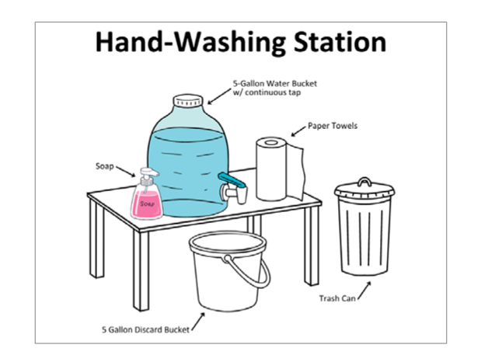
  - a five gallon or larger insulated container containing water with a continuous flow spigot. (09225)
- Check that all toilet facilities used by food workers have hand-washing facilities. (09230)
- Have a sign or poster that notifies food workers to wash their hands for at least twenty seconds.

4. Restrooms
Restroom access is important for ensuring your food workers practice adequate handwashing.
- Be sure that your food workers have access to toilet and hand washing facilities at all times of operation. (09230)

5. Garbage
Proper garbage disposal is crucial for food safety as it prevents contamination, pest infestations, and the spread of disease. Dirty, overflowing garbage bins can attract pests, contaminate food, equipment, and utensils, and create an environment where harmful bacteria can thrive.
For proper garbage disposal, make sure that:
- You have an adequate number of non-absorbent, easily cleanable garbage containers. (05515)
- Your garbage containers are rodent-proof and non-absorbent. (05525)
- You properly dispose of grease and avoid dumping it onto the ground surface or into the sanitary sewer system.
- You identify final disposal facilities for garbage, grease, and other waste materials that are approved by the [INSERT NAME OF TRIBAL DEPARTMENT].

6. Public Access to Food Preparation and Cooking Areas
Restricting public access is essential in food handling preparation areas to prevent contamination and protect event attendees.
- Make sure that the public is not able to access your food preparation areas and cooking areas. (09220)

7. Storage of Personal Items
Personal clothing and belongings stored in food preparations areas can cause contamination from dirty clothing, pathogens, or other contaminants.
Make sure to:
- Store personal clothing and belongings in a designated place in your temporary food establishment away from your food operations. (06410)

8. Toxic Materials
Toxic materials in food can be a serious health concern, and food safety practices aim to minimize these risks. Chemical hazards in food can result in adverse health outcomes.
To minimize the risks associated with toxic materials in foods, be sure to:
- Follow the labels for all toxic materials and store them in the right area;
- Store items in their original container and ensure they are properly labeled; and
- Avoid storing any chemicals near food operations.

9. Pest Control
Effective pest control is a critical component of preventing contamination and ensuring the safety of food products and consumers. Pests like rodents, insects, and birds can contaminate food, cause damage to food packaging, and potentially transmit diseases.
To reduce these risks, be sure to maintain your temporary food establishment free of insects, rodents, and other pests by doing the following:
- Maintain a clean and sanitary environment;
- Store food in sealed containers and away from walls and the floor;
- Regularly inspect your temporary food establishment for signs of pest activity so you can identify potential problems early on and prevent infestations; and
- Utilize professional pest control services if necessary.

WARE WASHING AND SINK EQUIPMENT
Maintaining food safety in a temporary food establishment heavily relies on proper ware washing and appropriate sink equipment.

1. Ware Washing Facilities
Proper ware washing is crucial for food safety as it eliminates bacteria and prevents cross-contamination on dishes and utensils. Use the following food safety techniques to eliminate these risks:
- Wash, rinse, sanitize, and air-dry dishes and utensils.
- Store extra utensils to reduce the need for washing.
- If possible, use a three-compartment ware washing sink with an adequate supply of hot and cold water and drainboards within 200 feet of operations if equipment/utensils are re-used on site OR operations of two or more consecutive days. (09235)
- If you do not have a three-compartment sink, set up three sturdy plastic or stainless steel containers sized to immerse all items provided for utensil cleaning and sanitizing using the following three step process:
  - Step 1: One container shall be used to wash (hot, soapy water).
  - Step 2: One container shall be used to rinse (clean, clear water).
  - Step 3: One container shall be used to sanitize (liquid chlorine bleach/water solution or other approved sanitizing solution). If using liquid bleach, use 1 tsp. of chlorine bleach per 1 gallon of water equal to 50 to 100 ppm. Use a chlorine test strip to verify proper sanitizer solution strength of 50 to 100 ppm.
Change your container contents as needed to maintain the water and solutions in a clean condition.
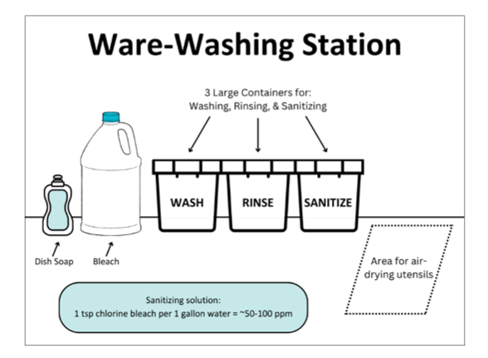

- Use a 100 PPM concentration of bleach at the same water temperature to wash down tabletops, counter tops and all in place equipment. Use a chlorine test kit (found at most restaurant supply outlets) to assure the correct amount of bleach is being used.

2. Produce
Produce can be a source of foodborne illness if not handled and stored properly. To prevent illness, it is crucial to follow these basic food safety guidelines:
- If possible, purchase pre-washed produce which does not have to be washed in a food preparation sink.
- If you are using produce that is not pre-washed, you want to ensure you wash your produce in a food preparation sink with potable water plumbed to a [INSERT NAME OF TRIBAL DEPARTMENT] approved wastewater system with an indirect connection (09240). If you do not have a food preparation sink, you may consult with the [INSERT NAME OF TRIBAL DEPARTMENT] about using a separate gravity flow container (container with hands-free dispensing valve with a catch bucket). (09240)

WATER SUPPLY AND WASTEWATER DISPOSAL
Safe water is crucial for food safety as it can contaminate food through irrigation, processing, or direct contact. Microbial contamination in water can introduce pathogens like Salmonella, E. coli, and Listeria, impacting food safety. The following proper water treatment, hygiene, and safety protocols are essential to prevent foodborne illness:

1. Water
- Make sure your water comes from a public water source approved by the Tribe. (05145(1))

2. Water System
- If you have your own water supply system or intend to connect to a potable water supply, be sure that the materials are National Sanitation Foundation (NSF) approved.
- If you are connecting to a potable water supply, be sure to install your equipment in a manner that avoids the backflow of contaminants into the potable water supply (e.g. vacuum breaker). (05200, 05205, 05215)

3. Wastewater Disposal
- Wastewater shall be disposed in an approved wastewater disposal system in accordance with the Tribe’s requirements.
- Wastewater must be removed from your temporary food establishment at an approved waste servicing area or by a sewage transport vehicle in conjunction with an approved plan of operation or as otherwise instructed by the Tribe [INSERT NAME OF TRIBAL DEPARTMENT]. (05425)
- Wastewater may not be dumped onto the ground surface, into waterways, or into storm drains, but shall be collected and dumped into a receptacle approved by the [INSERT NAME OF TRIBAL DEPARTMENT]. (05420)
- Make sure your wastewater tanks are large enough to handle your busiest days and consider having a back-up tank. (09225)
- Make sure your wastewater holding tank is at least 15% larger than the freshwater holding tank.

FOOD SERVICE WORKERS
All food workers involved in your temporary food establishment have a responsibility to ensure food safety. This includes understanding the basics of food safety and practicing good hygiene to prevent contamination. A positive food safety culture, where everyone understands and takes responsibility for food safety, is crucial.

1. Food Worker Card
- Make sure all your food works have an onsite copy of their valid food worker card issued by a Tribe, Indian Health Service, or [INSERT STATE(S)].

2. Handwashing
- Wash hands for at least 20 Seconds using plenty of soap and water
- Wash hands frequently, including:
  - Before
    - Starting work
    - Immediately before food preparation and related activities
    - Changing gloves
  - After
    - Using the restroom. Restroom handwashing sinks cannot replace your handwashing station. Food workers must wash their hands twice after visiting the restroom– once in the restroom and once at the food service area.
    - Sneezing
    - Coughing
    - Touching raw food
    - Touching face or hair
    - Eating or drinking
    - Emptying garbage
    - Smoking
    - Any chance of contamination

3. Hygiene
- Hair must be either completely pulled back or worn under a hat or hair net. (02410)
- Consume food (including chewing gum and tobacco) outside the food preparation areas.
- For your personal hydration needs, use closed beverage containers when in the food preparation area. (02400)

4. Bare Hand Contact
- Do not contact exposed, ready-to-eat foods with your bare hands. Use suitable utensils such as deli tissue, spatulas, tongs, single-use gloves, or dispensing equipment. (03300)
- Make sure you have an adequate supply of gloves.

5. Food Worker Health
- Stay home and do not work if you have any of the following:
  - Diarrhea, vomiting, sore throat with fever, or jaundice (yellow skin or eyes);
  - A lesion containing pus such as a boil or infected wound that is open or draining and is:
    - On the hands or wrist;
    - On exposed portions of the arms; or
    - On other parts of the body, unless the lesion is covered by a dry, durable, tight-fitting bandage; or
    - An illness diagnosed by a health provider as due to an infection with norovirus, hepatitis A virus; Shigella spp., shiga toxin-producing escherichia coli, salmonella Typhi (Typhoid fever), or salmonella (nontyphoidal)

ALLOWABLE FOOD SOURCES
To maintain food safety, it is crucial to ensure food sources are approved and adhere to regulations. Be sure to:
- Source all foods (including ice) from an approved source (e.g., grocery store, restaurant) or from a source allowed by [INSERT NAME OF TRIBAL DEPARTMENT].
- Prepare your food onsite or in an inspected and approved commissary or kitchen. Make sure not to serve foods that have been sourced from or prepared in a personal home unless otherwise allowed by the [INSERT NAME OF TRIBAL DEPARTMENT].
- Make sure not to prepare ice at home or other location that is not a commissary or community kitchen.

TEMPERATURE CONTROL
To ensure food safety, temperature control is crucial. High risk foods, also known as Time/Temperature Control for Safety foods, are foods which have a high risk for bacterial growth (e.g. meats, poultry, fish, eggs, dairy products, cooked grains, and cut vegetables). These foods need to be kept at specific temperatures to prevent foodborne illness.

Temperature Measuring Device
- Monitor the temperature of your foods with a stem-type thermometer or thermocouple capable of measuring all proper food temperatures. (09210)
- Ensure your food temperature measuring devices are accurate to ±2°F and have a suggested range of 0°F to 220°F. (04220)
- Regularly calibrate your temperature measuring devices to ensure accurate food temperature measurements.

Hot and Cold Holding Equipment Preparation
You can take the following steps to make sure your hot and cold holding equipment maintain your foods at the right temperature:
- Make sure your hot holding equipment is capable of maintaining high risk foods at 135°F or above at all times including during transport. (09210)
- Make sure that your cold holding equipment is capable of maintaining high risk foods at 41°F or below at all times including during transport. (03525)
- Warm insulated carriers (e.g., Cambro) with hot water 1 hour before use.
- Turn on electric warmers for service at least 30 minutes before use.
- Add ice to coolers ahead of placing food inside.

Holding and Cooking Temperatures
Maintaining the proper holding and cooking temperatures for high risk foods prevents the growth of harmful bacteria and ensures food remains safe for consumption over extended periods.
- Maintain high risk foods at 135°F or higher, or 41°F or below. (03525)
- Cook food to at least the minimum final cook temperature as indicated in the chart below.

Food Item or Reheated Foods | Final cook Temperature
- Vegetables, fruits, grains  - Reheating commercially processed foods (e.g. hot dogs) | 135°F or greater
- Eggs, seafood, and intact meat (e.g., beef steak) | 145°F or greater (must be held at this temperature for at least 15 seconds)
- Ground/chopped/minced/pinned or injected meats (e.g., sausages, hamburger, chopped or ground fish) | 158°F or greater
- Poultry, casseroles, stuffed foods or stuffing  - Reheating foods cooked in a food establishment | 165°F or greater

Cooling and Cold Holding
- Do not cool high risk foods in your temporary food establishment (09210). Offsite cooling may be allowed at an approved commissary kitchen or food establishment.
- If you use ice to cold hold high risk foods at 41°F or below, make sure that it is from an approved source and protected from contamination. (03260)
- Keep cut leafy greens such as lettuce, spinach, cabbage, and cut tomatoes at 41°F or less.
- Foods should not come in direct contact with ice unless they are in a package or container with the following exceptions:
  - whole, raw fruits, or vegetables; and
  - raw poultry and raw fish that are received on ice in shipping containers. (03327)

Reheating for Hot Holding
- Do not reheat food more than one time. (09210)
- High risk food that is cooked, cooled, and reheated for hot holding shall be rapidly reheated so that all parts of the food reach a temperature of at least 165°F for 15 seconds within one hour. (09210)
- Un-opened, intact, commercially processed, and packaged foods to be hot held shall be reheated to 135°F. (03440)
- Discard hot held foods at the end of the day.
- You can use crock pots for hot holding but be sure not to use them for reheating food.

Thawing
- Be sure not to thaw food at room temperature.
- Thaw high risk frozen foods as follows:
  - in the refrigerator;
  - as part of a continuous cooking process (i.e. hamburgers, hot dog, and French fries). Make sure that foods thawed as part of a continuous cooking process are not more than four inches thick (09215);
  - thawing under cold running water (70°F or lower) in an approved food preparation sink, provided the food is completely submerged and thawed quickly. Make sure the thawing period does not let the temperature of the food exceed 41°F. The water should flow sufficiently to agitate and remove impurities; or
  - in an insulated container with enough ice to maintain 41°F. Be sure to keep the food covered during the thawing process so as not to allow direct contact with the ice and uneven thawing from external heat sources such as nearby cooking equipment or sunlight.
- If using a microwave to thaw foods, always cook immediately after

TRANSPORT, STORAGE, AND HANDLING
Ensuring food safety during transport, storage, and handling involves maintaining proper temperatures, preventing contamination, and following safe handling practices. This includes keeping food in the proper temperature zone, using clean vehicles and sanitized equipment, and properly segregating raw and cooked foods.

1. Food Transport
- Transport food in food-grade containers properly designed to protect food from contamination and maintain proper food temperatures.
- Maintain safe hot (135°F or above) and cold (41°F or below) food temperatures during food transport and storage.

2. Storage
- Properly store all your food, equipment, utensils, and single-service items off the ground or floor, protected from contamination, and provided with effective overhead protection.
- Store your food at your temporary food establishment or an approved commissary (e.g. restaurant, church, school or community center).
- Foods should not be stored at home unless the food does not require refrigeration or is ready to eat in an intact commercial package.
- Date mark high-risk, refrigerated foods that are prepared on-site or opened and held for more than 24 hours. The date mark should show when the high-risk food must be consumed, sold, or discarded. Have a consistent system for date marking, whether using the preparation/opening date or the discard date. Make sure your date marking system is made clear to staff.

3. Cross Contamination and Environmental Contamination
- Protect food from cross contamination during transportation, storage, preparation, holding, and display by separating different types of raw animal foods from ready-to-eat foods.
- Thoroughly clean and sanitize equipment and utensils (including knives, cutting boards, and food storage containers) after being used for raw animal foods and before being used for ready-to-eat food. (04600; 04705)
- Protect food from potential environmental contamination (e.g., dust, flies, spills, sneezes) during transport, storage, and service.

4. Food Display
Proper food display helps prevent contamination of food items by food workers, patrons, insects, or other sources. Be sure to:
- Wrap foods and/or using food shields or other effective methods or alternatives that protect food from customer handling, coughing, sneezing or other contamination. (03369)
- Dispense condiments in single-service type packaging, pump-style dispensers, or in protected squeeze bottles, shakers, or similar dispensers. (03366)

CLEANING AND SANITIZING
Cleaning and sanitizing can significantly lower the risk of foodborne illness by reducing the amount of harmful bacteria on equipment and surfaces to safe levels.

Equipment Food-Contact Surfaces and Utensils
- Clean and sanitize your equipment food-contact surfaces and utensils as follows:
  - when changing from working with raw foods to working with ready-to-eat foods;
  - between uses with raw fruits and vegetables and with high-risk food; and
  - before using or storing a food temperature measuring device.
- Clean equipment food-contact surfaces and utensils that are used with high-risk foods at least every 4 hours and at any time when contamination may have occurred. (04605)

Garbage Cans
- Regularly clean your trash cans to prevent the buildup of food residue and bacteria.

Ware Washing
- Be sure to have ware washing methods available to wash, rinse, and sanitize all food contact equipment/utensils.

Sanitizing
- Make sure to have approved sanitizers for food-contact surfaces, equipment, and wiping cloths. (07220)
- Use sanitizers in accordance with the label use instructions. (07210)
- Make sure to have an approved test kit to accurately measure the concentration of sanitizing solutions. (04575, 04710)

Wiping Cloths
- Use wiping cloths only for wiping food spills and not for other purposes.
- Make sure to store wiping clothes in a sanitizing solution. (03339)
- Store wiping clothes not in use in a clean and dry location.

