Governor’s Indian Health Council
Improving Indian Health Care in Washington State

December 21, 2018

Engrossed Substitute Senate Bill 6032, Section 213; Chapter 299, Laws of 2018

Governor’s Indian Health Council
Improving Indian Health Care in Washington State

Acknowledgements
This report was written by the Health Care Authority, in collaboration with the American Indian Health Commission for Washington State, on behalf of the Governor’s Indian Health Council. The council reviewed and approved the recommendations contained in this report on December 20, 2018. We thank the members of the council for their time and contributions in the development of this report.
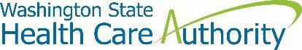 | 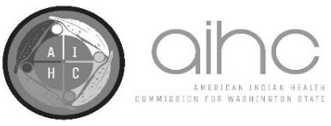
P.O. Box 45502  Olympia, Washington 98504  Phone: (360) 725-1649  www.hca.wa.gov | 808 North 5th Avenue Sequim, Washington 98382  Phone: (360) 477-4522  www.aihc-wa.com

Table of Contents
Table of Contents 1
Executive Summary 2
Background 3
Health Disparities 3
Adverse Childhood Experiences and Historical Trauma 5
Limitations of Evidence-Based Practices 6
Examples of Proven Practices 7
Barriers 9
Federal Funding Deficiencies for Indian Health Care 9
New CMS Policy for Additional Medicaid Federal Match 12
Estimates for Potential Savings to State General Fund 13
Recommendations 16
Appendix A: Fiscal Estimates 18
Appendix B: Proposed Legislation 22

Executive Summary
In 2018, the Washington State Legislature passed Engrossed Substitute Senate Bill (ESSB) 6032, which included proviso language to establish the Governor’s Indian Health Council. The council includes tribal leaders, urban Indian health leaders, representatives of the Governor’s office, state agency leaders, and legislators to address issues in Washington State’s Indian health care delivery system. The council convened on July 16, November 7 and 8, and December 11 and 20, and approved this report to the Governor and the Legislature during the December 20 meeting. As specified in the proviso, this report provides the following recommendations for the state:
- Establish the Governor’s Indian Health Advisory Council to:
  - Adopt a biennial Indian Health Improvement Advisory Plan;
  - Address issues with tribal implications that are not able to be resolved at the agency level; and
  - Provide oversight of the Indian Health Improvement Reinvestment Account.
- Establish an Indian Health Improvement Reinvestment Account into which the new state savings due to the new 100 percent Federal Medical Assistance Percentage (FMAP), less agreed upon administrative costs to maintain fiscal neutrality, will be appropriated and deposited (subject to federal appropriations).
- Appropriate sufficient funding for five full-time equivalent (FTE) Health Care Authority (HCA) staff (approximately $500,000 in salaries and benefits, as included in HCA decision package #37 and the Governor’s 2019–2021 proposed budget) to partner with the Indian Health Service (IHS) and tribal governments to meet federal requirements that allow the state to receive the 100 percent FMAP on services currently provided to American Indians/Alaska Natives (AI/AN) Medicaid enrollees at standard FMAP rates.
- Partner with tribes to cover the expenses for meetings and related costs for the Governor’s Indian Health Advisory Council to complete the first Indian Health Improvement Advisory Plan by November 1, 2019, which will include all of the analyses described in section 213(mmm) of ESSB 6032.
Fiscal budget estimates and draft legislation to support the recommendations are in the appendices to this report.

Background

Health Disparities
American Indians/Alaska Natives (AI/ANs) in Washington State suffer some of the greatest health disparities of any racial/ethnic group.1 Using state and tribal data, the Northwest Tribal Epidemiology Center (NWTEC) determined that the overall premature mortality rate for AI/AN for 2006 through 2010 was 71 percent higher than for non-Hispanic whites.2 NWTEC also prepared Chart 1 with the top five premature mortality rates for AI/AN and non-Hispanic whites.2 As shown in Chart 1, AI/ANs have significantly higher rates of premature death due to heart disease (67 percent higher), cancer (18

Chart 1: Top 5 Premature Mortality Rates Washington State
NWTEC, 2006-2010

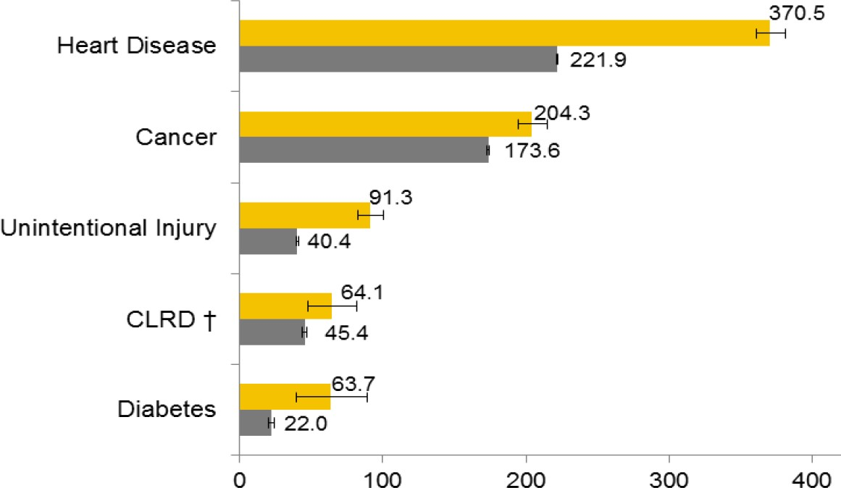
Age-Adjusted Rate per 100,000
† CLRD = Chronic Lower Respiratory Disease
= American Indian/Alaska Native
= Non-Hispanic White
percent higher), unintentional injury (126 percent higher), chronic lower respiratory disease (41 percent higher), and diabetes (186 percent higher).
Due to the complex analysis required to prepare these more complete data, the most recent NWTEC report is based on 2014 data. More recent state-only premature mortality data, as published in the 2018 Washington State Health Assessment, reflect similarly significant premature mortality rates

1 Notes on Data:
- There is no single source of health data on AI/ANs. Each tribe has its own data, which are reported to the Indian Health Service (IHS). Separately, the Washington Department of Health maintains vital statistics data, as well as sample-based data, such as the Healthy Youth Survey (HYS) and the Behavioral Risk Factor Surveillance System (BRFSS). A complete picture requires knowledge of, and work with, these diverse data sets.
- There is no single policy on how to identify AI/AN individuals. While tribes identify individuals as AI/AN even if they self-identify as two or more races, the state categorizes individuals who self-
identify as two or more races into a separate “Two or More Races” category, leaving in the AI/AN category only those individuals who self-identify as AI/AN only. As a result, the state’s data on the AI/AN population reflects less than half of the state’s total AI/AN population.
2 Northwest Tribal Epidemiology Center (NWTEC). (2014). American Indian and Alaska Native community health profile - Washington. Portland, Oregon: Northwest Portland Area Indian Health Board. Available at http://www.npaihb.org/idea-nw/

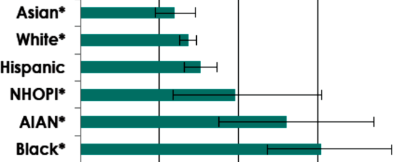for AI/ANs as compared to the other race categories — keeping in mind that the state’s racial category data do not include individuals who self-identify with more than one racial category.3
Rate per 1,000 Live Births
9
6
3
0
Chart 2: Infant Mortality by Maternal Race Washington State
DOH, 2013-2015
- Infant mortality rate for AI/AN mothers is nearly twice the rate for non-Hispanic white mothers (Chart 2).
- Completed suicide rate for AI/AN is much higher than for any other race (Chart 3).
- 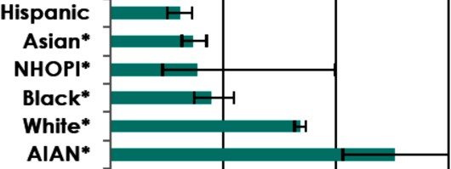Drug overdose mortality rate for AI/AN is more than twice the rate for non- Hispanic whites (Chart 4).
Age-Adjusted Rate per 100,000
30
20
10
0
Chart 3: Suicide Washington State DOH, 2011-2015
The disparities continue across the spectrum of chronic diseases and mental illnesses. Compared to non-Hispanic whites, AI/ANs have significantly higher rates of:
- Asthma;
- Coronary heart disease and hypertension;
- Diabetes, pre-diabetes, and obesity;
- Dental caries in third grade;
- 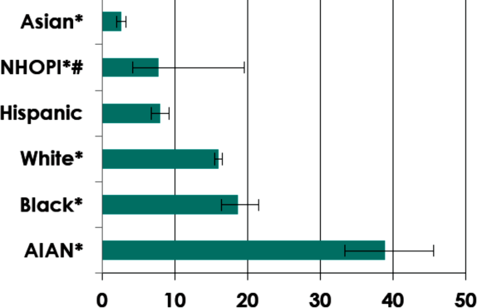Poor mental health and youth depressive feelings;

Chart 4: Drug Overdose Washington State DOH, 2012-2016

Age-Adjusted Rate per 100,000
- Adult and youth cigarette smoking and
vaping;
- Adult and youth cannabis use; and
- Fetal alcohol spectrum disorder.3

Adverse Childhood Experiences and Historical Trauma
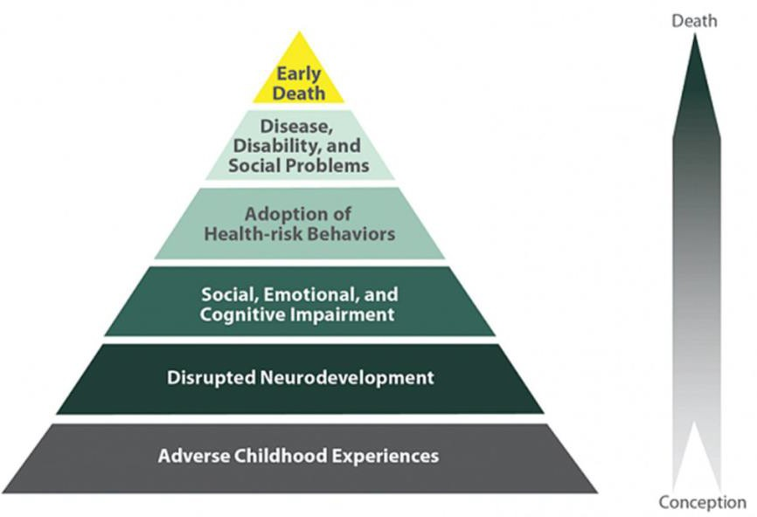Higher rates of poor health and poor health outcomes — as reflected in the health disparities data — have been associated with higher rates of adverse childhood experiences (ACEs).4 When ACEs disrupt neuro- development and impair social, emotional, and cognitive growth, individuals adopt health-risk behaviors that lead to disease, dis- ability, and social problems

Diagram 1: Impact of Adverse Childhood Experiences on Health
- 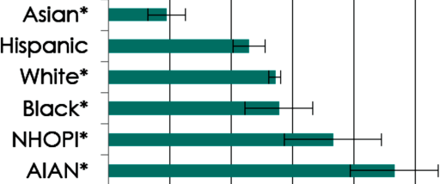resulting in premature mortality; see Diagram 1 for a visual representation.4

Chart 5: ACEs Scores 3-10 Washington State DOH, 2009-2011

0 10 20 30 40 50
Age-Adjusted Percent

Measured by a 10 question screening tool, ACEs are various forms of childhood trauma in the home, including emotional, physical, or sexual abuse; neglect; and other household challenges during childhood. The ACEs score has been used as a measure of cumulative exposure to traumatic stress in childhood. As shown in Chart 5, AI/AN adults reported nearly twice the rate of 3+ ACEs compared to non-Hispanic white adults.5 These data mean that between 39 percent and 54 percent of AI/AN adults reported childhood exposure to 3 or more traumatic
family stressors, compared to 26 percent of non-Hispanic white adults.

In AI/AN communities, these disparately high rates of adverse childhood experiences are a direct result of historical trauma, which becomes intergenerational trauma through repeating cycles of ACEs over generations. Historical trauma refers to situations where a community experienced traumatic events, the events generated high levels of collective distress, and the events were

4 Felitti, V. J., Anda, R. F., Nordenberg, D., Williamson, D. F., Spitz, A. M., Edwards, V., & Marks, J. S. (1998). Relationship of childhood abuse and household dysfunction to many of the leading causes of death in adults: The Adverse Childhood Experiences (ACE) study. American Journal of Preventive Medicine, 14(4), 245-258.

perpetuated by outsiders with a destructive or genocidal intent.6 One of the challenges in comprehending the impacts of historical trauma is the term “historical;” when hearing the word, people tend to think of something in the past. The effects of historical trauma, however, manifest in the everyday experience of AI/AN communities today — in the ways they relate to one another, in their bodies, and in their daily thoughts. First studied in World War II holocaust survivors, historical trauma in AI/AN communities resulted from the legacy of genocide, a century of socio- cultural destruction through forced relocation and boarding schools, and continuing racial discrimination and socio-economic poverty.7
Responses to historical trauma at the individual level may include post-traumatic stress disorder, guilt, anxiety, grief, and depression. Responses at the familial level may include impaired family communication and stress around parenting.8 The burdens of historical trauma weigh heavily on AI/AN youth, with 1 in 6 thinking daily or several times a day about loss of trust, family, and respect.9 More recently, historical trauma has been found to have epigenetic impacts across generations, as historical trauma and ACEs alter gene expression that is then epigenetically transmitted to future generations.10

Limitations of Evidence-Based Practices
In the face of this historical/intergenerational trauma, adverse childhood experiences, and resulting health disparities, the quality of care that AI/ANs receive is “that much more important.”11 Yet, few research-based and evidence-based practices (EBPs) have been tested in tribal communities. Those that have been developed from AI/AN communities can be expensive to implement and maintain.
Moreover, the diversity of tribal communities can limit the efficacy of EBPs, particularly if they were normed in such a way as to be particular to some tribal communities and cultures but not others.

6 Evans-Campbell, T. (2008). Historical trauma in American Indian/Native Alaska communities: A framework for exploring impacts on, individuals, families, and communities. Journal of Interpersonal Violence, 23(3), 316– 338.
7 Wesley-Esquimaux, C. C., & Smolewski, M. (2004). Historic trauma and Aboriginal healing. Ottawa, Ontario: Aboriginal Healing Foundation.
8 Yellow Horse Brave Heart, M., & DeBruyn, L. M. (1998). The American Indian holocaust: Healing historical, unresolved grief. American Indian and Alaska Native Mental Health Research, 8, 56–78.
9 Whitbeck, L.B., Walls, M.L, Johnson, K.D., Morrisseau, A.D., & McDougall, C.M. (2009). Depressed affect and historical loss among North American indigenous adolescents. American Indian and Alaska Native Mental Health Research, 16(3), 16-49.
10 See, e.g., Kuzawa, C.W., & Sweet, E. (2009). Epigenetics and the embodiment of race: Developmental origins of U.S. racial disparities in cardiovascular health. American Journal of Human Biology, 21(1):2–15; Bird, A. (2007). Perceptions of epigenetics. Nature, 447, 396–398.
11 Washington Health Alliance. (2014). Disparities in care 2014 report. Seattle, Washington. Available at https://wahealthalliance.org/alliance-reports-websites/alliance-reports/

Due to this diversity of tribal communities and cultures, the only way to ensure a high quality of services is through direct interaction with tribes and AI/AN communities to ensure the practices are culturally appropriate.12 This is true whether the practices are EBPs or promising practices, because culture mediates health care.13 For example, AI/AN cultures have a holistic and relationship-oriented view of health and well-being. As a result, treatments that focus only on parts of the individual without working on healing the family and the spirit will likely not be successful — even when they are evidence-based.14 Without the flexibility to adapt EBPs or to implement promising practices, EBPs are likely to result in poor health outcomes. The only EBPs that are likely to result in better health outcomes are those based on the specific tribal community.

Examples of Proven Practices
Family Spirit15 is a culturally tailored, evidence-based home-visiting model used by more than 100 tribal communities across the nation. This model addresses intergenerational behavioral health problems, applies local cultural assets, and overcomes deficits in the professional healthcare workforce in low-resource communities. Designed for, by, and with AI/AN families, community- based paraprofessionals deliver culturally appropriate, behaviorally-focused interventions to support young parents from pregnancy through three years post-partum. A tribal community can link this program to other programs, such as Women, Infants, and Children (WIC), behavioral health, Head Start, Indian Child Welfare, domestic violence intervention, and substance use disorder programs.
Pulling Together for Wellness16 is a comprehensive, culturally-grounded prevention framework based on a policy, systems, and environmental change approach. The framework was co-designed through the guidance of Washington tribal and urban Indian leaders with input from elders, youth, students, communities, program staff, and public health specialists. It adapts evidence-based practice by integrating western science and native ways of thinking. The approach uses the medicine wheel model — a holistic view of health including emotional, social, physical, and spiritual health. It honors the native values of the particular community seeking change, using a culturally appropriate and community-specific process to engage multiple sectors, including community members, in decision making. The Shoalwater Bay Indian Tribe adopted this framework to improve the health of tribal members for seven generations by embracing the traditions of their ancestors to

12 Woolf, S., Grol, R., Hutchinson, A., Eccles, M., & Grimshaw, J. (1999). Potential benefits, limitations, and harms of clinical guidelines. BMJ, 318(7182).
13 Kleinman, A., Eisenberg, L., & Good, B. (1978). Culture, illness and care: Clinical Lessons from anthropologic and cross-cultural research. Annals of Internal Medicine, 88, 251-258.
14 Larios, S., Wright, S., Jernstrom, A., Lebron, D., & Sorensen, J. (2011). Evidence-based practices, attitudes, and beliefs in substance abuse treatment programs serving American Indians and Alaska Natives: A qualitative study. Journal of Psychoactive Drugs, 43(4), 355-359.
15 Johns Hopkins University, Center for American Indian Health. (2018). Family spirit home visiting program. Available at http://caih.jhu.edu/programs/family-spirit/
16 American Indian Health Commission for Washington State. (2018). Pulling together for wellness, Available at https://aihc-wa.com/pulling-together-for-wellness/

change the norm. In recognition of their successful implementation, the Tribe received the Robert Wood Johnson Foundation Culture of Health prize in 2016.
The Healing of the Canoe Project17 is a collaborative project between the Suquamish Tribe, the Port Gamble S’Klallam Tribe, and the Alcohol and Drug Abuse Institute at the University of Washington. Suquamish and Port Gamble S’Klallam both identified the prevention of youth substance abuse and the need for a sense of cultural belonging and cultural revitalization among youth as primary issues of community concern. The Healing of the Canoe partnership has sought to address these issues through a community based, culturally grounded prevention and intervention life skills curriculum for tribal youth that builds on the community’s strengths and resources The Culturally Grounded Life Skills for Youth Curriculum uses the Canoe Journey as a metaphor, providing youth the skills needed to navigate their journey through life without being pulled off course by alcohol or drugs — with tribal culture, tradition, and values as a compass to guide them, and an anchor to ground them. One key element of this program’s success is the ability to adapt the Healing of the Canoe Project to different tribal communities and cultures.
Nuka System of Care18 is a whole health care system (medical, dental, behavioral, traditional, and health care support services) based on the recognition that the relationship between the primary care team and the client (also known as the customer-owner) as the single most important tool in managing chronic disease, controlling health care costs, and improving the overall wellness of a population. Recognizing that individuals are ultimately in control of their own lifestyle choices and health care decisions, Nuka focuses on understanding each customer-owner’s unique story, values, and influencers, in an effort to engage them in their care and support long-term behavior change. Nuka also focuses on growing health professionals — encouraging medical assistants to become registered nurses, nurses to become advanced registered nurse practitioners (ARNPs), and ARNPs to become physicians through education scholarships. In recognition of their success with Nuka, the Southcentral Foundation received the Malcolm Baldridge National Quality Award in 2011 and 2017.
Wisdom Warriors19 is a chronic disease prevention and control program that provides tribal elders education and tools to make healthier lifestyle choices. The Northwest Regional Council and the Administration for Community Living partnered with Washington tribes to locally adapt the
Minnesota tribes’ Wisdom Steps program.20 It incorporates the Stanford chronic disease self- management model using culturally appropriate incentives for making positive lifestyle changes. Tribal elders practice good preventive health by having health screenings and participating in healthy living activities. The National Indian Health Board has recognized this program, and the Department of Health has stated that it has been instrumental to falls prevention.

17 Healing of the Canoe. (2018). Available at http://healingofthecanoe.org/
18 Nuka System of Care, Southcentral Foundation (2018). Available at https://scfnuka.com/
19 Northwest Regional Council. (2013). Wisdom Warriors: Living Wise…Living Strong. Available at https://www.ncoa.org/wp-content/uploads/WA-Wisdom-Warriors-description-2013.pdf
20 Wisdom Steps: Preventive Health for American Indian Elders. (2013). Available at https://wisdomsteps.org/

A Gathering of Wisdoms21 is a culturally and spiritually informed behavioral health counseling model. Mental health providers of the Swinomish Indian Tribal Community and the Upper Skagit Tribe cooperatively developed the program with input from tribal elders. This counseling model draws from traditional Indian healing.

Barriers
Tribes and other Indian health care providers experience many barriers to providing culturally appropriate care. Burdensome reporting requirements and reimbursement processes impose administrative hurdles to financing and sustainability. Poor access to broadband internet and outdated computer and information systems interfere with the ability to use technology to improve care and to remotely report home care treatment hours on-site. All tribes and other Indian health care providers are considered health professional shortage areas, reflecting the challenges of recruiting and retaining health care professionals. Various loan repayment and forgiveness programs for health care professionals have mitigated — but not solved — the shortage of health care professionals at tribes and other Indian health care providers.
A bigger barrier — perhaps the biggest barrier — is the chronic underfunding of Indian health care nationwide.

Federal Funding Deficiencies for Indian Health Care
The health care delivery system for AI/ANs in the United States is complex and unique, resulting from treaty obligations, federal court cases, and federal laws.22 Since 1955, Congress has funded health care delivery through the IHS, a federal agency within the U.S. Department of Health and Human Services. Originally an agency that provided health care and related services, IHS has only three service units remaining today in Washington State. The IHS service units provide health care services on three Indian reservations in eastern Washington. Under the Indian Self-Determination and Education Assistance Act of 1975, every tribe in Washington State has contracted to administer some or all of their health care programs funded through IHS. In addition, under the Indian Health Care Improvement Act, Congress authorized the establishment of urban Indian health programs to serve AI/ANs in metropolitan areas to fulfill the special trust responsibility to AI/ANs who could not access health care from an IHS or tribal facility; the urban Indian health programs in Washington operate in Seattle and Spokane. In 2018, Congress appropriated approximately $5.5 billion for all IHS-funded projects and programs.

21 Swinomish Tribal Mental Health Project. (2002). A gathering of wisdoms: Tribal mental health, a cultural perspective (2nd ed). La Conner, Washington: Swinomish Indian Tribal Community.
22 For a brief description of the history of the special trust responsibility to provide health care to American Indians and Alaska Natives, see Warne, D., & Frizzell, L.B. (2014). American Indian health policy: Historical trends and contemporary issues. American Journal of Public Health, 104(Suppl 3), S263–S267. Available at https://www.ncbi.nlm.nih.gov/pmc/articles/PMC4035886/

Yet, Congress persistently underfunds health care for AI/ANs. For example, as shown in Chart 6, IHS per capita funding for health care delivery increased minimally from $2,741 in 2010 to $2,834 in 2016. With the growth in overall health care spending per capita from $8,411 to $10,410, the ratio of IHS spending to overall spending actually declined from 33 percent in 2010 to 27 percent in 2016. In its December 20, 2018 publication,23 the U.S. Commission on Civil Rights described other aspects of this underfunding, including IHS funding being subject to full sequestration and IHS budgets not receiving advance appropriations, both of which impede any planning for the future.
All Health Care Spending
2016
2015

IHS
2014

Medicaid
2013
2012
2011

Medicare
2010
$14,000
$12,000
$10,000
$8,000
$6,000
$4,000
$2,000
$-
Chart 6: National Health Care Spending per Capita, 2010-2016
Data Sources: National Health Expenditure Accounts (NHEA) Table 1 for All Health Care Spending per capita and Table 21 for Medicare and Medicaid Spending per enrollee; National Congress of American Indians Fiscal Year Indian Country Budget Requests: Healthcare for IHS Spending per user.
In June 2018, the IHS Indian Health Care Improvement Fund Workgroup issued an interim report on their attempt to establish a methodology for estimating the percentage of need currently met by IHS appropriations;24 see Table 1 for data drawn from that report. Using the per capita amounts from that report, along with the numbers of AI/AN Medicaid enrollees and AI/AN individuals in Washington State, we estimate in the last two lines of Table 1 the total amounts of funding needed in Washington State to bring spending for AI/AN health care up to the average spent nationwide on health care for both populations — by category of services. As shown in Table 1, approximately
$898 million per year of additional funding would be necessary to bring health care spending on all AI/ANs in the state up to the same level as what is spent on health care for all U.S. residents. These estimates do not take into account any additional funding that would be necessary to address the severe health disparities reflected above.

23 U.S. Commission on Civil Rights. (2018). Broken promises: Continuing federal funding shortfall for native Americans. Washington, DC: Author.
24 Data from Interim Report (June 2018) IHS Indian Health Care Improvement Fund Workgroup. Rockville, Maryland.

The public and private insurance payments shown in Table 1 reflect third party payments from Medicaid, Medicare, and commercial insurance. These payments result from federal requirements, particularly Medicaid requirements, to ensure payments to IHS and tribal health programs for services. In addition, under federal law, AI/ANs are required to apply for and use Medicaid and other coverage, when eligible, for care received outside of IHS-funded health programs. IHS is a payer of last resort, last in line even after Veterans Affairs health care payments. Consequently, tribes need the state as a partner to help fulfill the special trust responsibility.

Table 1: Estimates of Annual Underfunding for AI/AN Health Care by Category
 | Medical and Non- Residential  Behavioral Health Care | Residential Behavioral Health Care, Long-Term Services, and School-Based  Services | Dental Care | Public Health | Total
National Per User Amounts
National Health Expenditures (NHE) | $7,749 | $1,329 | $393 | $255 | $9,726
Less: Public and Private Insurance Payments | ($1,937) | ($598) | ($39) | — | ($2,574)
Less: IHS Funding2 | ($2,411) | ($105) | ($117) | ($176) | ($2,809)
Amount Underfunded | $3,400 | $626 | $236 | $79 | $4,341
Calculations of Total Underfunded Amounts = National Per User Amounts multiplied by:
- 71,74225  AI/AN  Medicaid Enrollees | $243,922,800 | $44,910,492 | $16,931,112 | $5,667,618 | $311,432,022
- 206,86026  AI/AN  Individuals | $703,324,000 | $129,494,360 | $48,818,960 | $16,341,940 | $897,979,260
Data Sources: National Per User amounts from National Health Expenditure Accounts and the Indian Health Service as reported by IHS Indian Health Care Improvement Fund Workgroup; Washington State AI/AN Medicaid Enrollees from HCA; Washington State AI/AN Individuals from the American Community Survey, 2011-2015.

25 HCA data: Total number of self-identified AI/AN Medicaid enrollees for October 2018.
26 American Community Survey, 2011-2015: Total estimated population of AI/AN, alone or in combination, for Washington State.

New CMS Policy for Additional Medicaid Federal Match
Reflecting the treaty obligations and special trust responsibility, the Centers for Medicare and Medicaid Services (CMS) have historically paid 100 percent Federal Medical Assistance Percentage of the Medicaid payments to tribal and IHS providers for health care services to AI/AN Medicaid clients. With 100 percent FMAP, the state incurs no expense to the General Fund – State for Medicaid payments for services provided to AI/AN Medicaid enrollees by tribal and IHS facilities.
In February 2016, CMS issued a State Health Official (SHO) letter27 announcing a regulatory change of interpretation. The SHO letter explained that the state can now receive 100 percent FMAP for Medicaid payments to non-IHS, non-tribal providers for health care services to AI/AN Medicaid clients. This 100 percent FMAP is only permitted if the services are covered by a written care coordination agreement between an IHS or tribal facility and a non-IHS, non-tribal provider, under which the IHS or tribal facility practitioner remains responsible for overseeing his or her AI/AN patient’s care and the IHS or tribal facility retains control of the patient’s medical record. To be eligible for 100 percent FMAP, a service must meet the following requirements:
- The IHS or tribal facility practitioner provides a request for specific services (by electronic or other verifiable means) and relevant information about his or her AI/AN patient to the non-IHS/non-tribal provider;
- The non-IHS, non-tribal provider sends information about the care it provides to the AI/AN patient, including the results of any screening; diagnostic; or treatment procedures, to the IHS or tribal facility practitioner;
- The IHS or tribal facility practitioner continues to assume responsibility for the patient’s care by assessing the information and taking appropriate action, including, when necessary, furnishing, or requesting additional services; and
- The IHS or tribal facility incorporates the patient’s information into the medical record through the Health Information Exchange or other agreed-upon means.
According to CMS, the purpose of the new 100 percent FMAP policy is to help states, IHS, and tribes to improve delivery systems for AI/ANs by increasing access to care, strengthening continuity of care, and improving population health.
In January 2017, CMS issued frequently asked questions28 on the SHO letter. In the FAQ, CMS explained that the rate paid for the service provided under the care coordination agreement by the non-IHS, non-tribal facility must be the standard rate applicable to the service as billed. CMS also
explained that a tribe’s health clinic can be automatically considered a Medicaid federally qualified health center (FQHC) if the tribe opts for that designation. As an FQHC, the tribal clinic may contract with non-IHS, non-tribal providers to provide services outside the clinic’s four walls.

27 State Health Official Letter #16-002, Federal Funding for Services “Received Through” an IHS/Tribal Facility and Furnished to Medicaid-Eligible American Indians and Alaska Natives, dated February 26, 2016. 28 Frequently-Asked Questions (FAQs) on Federal Funding for Services “Received Through” an IHS/Tribal Facility and Furnished to Medicaid-Eligible American Indians and Alaska Natives (SHO #16-002) dated January 18, 2017.

While the savings achieved from the new 100 percent FMAP interpretation accrue to the state, the required care coordination activities incur administrative costs to the IHS or tribal facility.
Moreover, the SHO letter explicitly states that the state may not require tribes or IHS facilities to enter into such care coordination agreements or incur the administrative costs required to comply with the requirements for the new 100 percent FMAP.

 | Hypothetical Comparison to Illustrate Shift in Source of Funds
Without New 100 Percent FMAP:  Tribal clinic refers AI/AN Medicaid-enrolled patient to non-tribal specialist. Specialist assesses patient and bills HCA for $100. If the patient is covered by a Classic Medicaid program with 50 percent FMAP, the sources of funds for the $100 are:  - State general fund: $50.  - Federal government: $50. |  | With New 100 Percent FMAP:  Tribal clinic enters into care coordination agreement with non-tribal specialist. Tribal clinic refers AI/AN Medicaid-enrolled patient to non-tribal specialist. Specialist assesses patient and sends medical records to tribal clinic. Specialist bills HCA for $100. Even if the patient is covered by a Classic Medicaid program with 50 percent FMAP, the new 100 percent FMAP would now apply, and the sources of funds for the $100 are:  - State general fund: $—.  - Federal government: $100.
Compliance with the requirements for the new CMS policy for the new 100 percent FMAP results in a transfer of $50 in Medicaid costs from the state general fund to the federal government.

Estimates for Potential Savings to State General Fund
Using Washington State Medicaid data, HCA has prepared three projection scenarios — pessimistic, baseline, and optimistic — in Chart 2 of the amounts of new savings to the state general fund that may be achieved as a result of the new 100 percent FMAP. To achieve these savings to the state general fund, tribes and IHS facilities will need to:
  - Enter into an estimated 300 care coordination agreements with non-tribal, non-IHS providers;
  - Develop processes and staffing to refer clients to non-tribal, non-IHS providers under these care coordination agreements;
  - Develop processes and staffing to receive medical records from non-tribal, non-IHS providers and incorporate those records into the client medical records; and
  - Ensure action is taken on the health information received from the non-tribal, non-IHS providers.

Chart 2: Savings to State General Fund by Year
$20,000,000

$15,000,000

$10,000,000

$5,000,000

$-
2019-20 2020-21 2021-22 2022-23 2023-24 2024-25

Pessimistic Scenario Baseline Scenario Optimistic Scenario
 | 2019-20 | 2020-21 | 2021-22 | 2022-23 | 2023-24 | 2024-25
Pessimistic | $- | $455,095 | $1,014,725 | $1,604,995 | $2,195,265 | $2,785,534
Baseline | $- | $910,191 | $2,081,717 | $3,314,524 | $4,547,331 | $5,780,137
Optimistic | $- | $1,820,381 | $5,141,201 | $9,791,255 | $14,400,751 | $16,626,635
Data generated from 2017 HCA Medicaid claims applied to three penetration rate models.

As explained above, the state may not require tribes or IHS facilities to engage in these activities that would generate savings to the state general fund — even as a condition for participating in the Medicaid program. More detailed information on the fiscal estimates are provided in Appendix A. To encourage tribes and other providers to enter into these arrangements, HCA could provide technical assistance to increase understanding of the benefits to the state and to the patients from entering into care coordination agreements with IHS facilities and tribal facilities.
The savings set forth in Chart 2, therefore, reflect two minimum investments out of the new savings to the state general fund to achieve the three scenarios shown:
- The state appropriates sufficient funding (estimated at $366,000 per state fiscal year) beginning in July 2019 for HCA to hire four regional tribal liaisons29 to provide technical assistance to tribes, IHS facilities, and other providers throughout the state on the CMS requirements for the new 100 percent FMAP and monitoring for compliance with CMS requirements; and
- The state provides a sufficient portion of the savings achieved from the new 100 percent FMAP to tribes and IHS facilities to cover their administrative costs for complying with the requirements for the new 100 percent FMAP (subject to federal appropriations).

29 See HCA decision package #37; during the tribal consultation with HCA on April 30, 2018, HCA and the tribes agreed for HCA to seek legislative approval for hiring four regional tribal liaisons.

More significantly, as CMS wrote in the SHO letter, the new 100 percent FMAP is intended to help states, IHS, and tribes to improve delivery systems for AI/ANs by increasing access to care, strengthening continuity of care, and improving population health.
With so many AI/AN health disparities, the need to cover the administrative costs of IHS facilities and tribes, and ranges of potential new savings to the state general fund between $455,095 and
$1,820,381 in state fiscal year 2020–2021 and between $2,785,534 and $16,626,635 in state fiscal year 2024–2025, this is an opportune moment for the state focus on improving AI/AN health and health care, including creating a mechanism to capture the savings to the state general fund due to the new 100 percent FMAP. These savings could then be reinvested to increase access to care, strengthen continuity of care, and improve population health for AI/ANs throughout the state, and, in some cases, coordinating these efforts with tribes and urban Indian organizations and health programs in border states.
To achieve these goals, the state should establish the Governor’s Indian Health Advisory Council, which will have the following roles:
  - Serving as the principal advisory body to HCA and the Department of Health on issues related to health and health care for American Indians and Alaska Natives;
  - Adopting a biennial Indian Health Advisory Plan, developed by the Reinvestment Committee of the Advisory Council comprised of Advisory Council members representing tribes and urban Indian organizations;
  - Addressing issues with tribal implications that are not able to be resolved at the agency level; and
  - Provide oversight of the Indian Health Improvement Reinvestment Account.

The Indian Health Advisory Plan will include the following:

  - An assessment of Indian health and Indian health care in the state;
  - Specific recommendations for programs, projects, or activities, along with recommended reinvestment account expenditure amounts and priorities for expenditures, for the next two state fiscal bienniums; and
  - A review of how programs, projects, or activities that have received investments from the reinvestment account have or have not achieved the objectives and why.
In addition, the State Treasurer, in consultation with the Office of Financial Management, should establish the Indian Health Improvement Reinvestment Account. Savings from the new 100 percent FMAP, less administrative costs agreed upon by the state and tribes and urban Indian organizations and health programs, would be appropriated and deposited into this reinvestment account.

Recommendations
To improve Indian health care outcomes and begin to remedy long-standing health disparities, the Council makes the following recommendations:
  - Establish the Governor’s Indian Health Advisory Council. The state should establish the Governor’s Indian Health Advisory Council, consisting of:
    - Voting members representing the tribes, urban Indian organizations and health programs, the governor’s office, and the majority and minority caucuses of the House of Representatives and the Senate; and
    - Non-voting members representing the American Indian Health Commission for Washington State, the Northwest Portland Area Indian Health Board, the IHS Portland Area Office and Service Units, and the state agencies involved in health care.
The Governor’s Indian Health Advisory Council will:
    - Adopt a biennial Indian Health Improvement Advisory Plan, developed by the reinvestment committee;
    - Address issues with tribal implications that are not able to be resolved at the agency level; and
    - Provide oversight of the Indian Health Improvement Reinvestment Account.

The Indian Health Improvement Advisory Plan will include the following:
    - An assessment of Indian health and Indian health care in the state;
    - Specific recommendations for programs, projects, or activities, along with recommended reinvestment account expenditure amounts and priorities for expenditures, for the next two state fiscal bienniums; and
    - A review of the successes and challenges of previously funded programs, projects, and activities.
In addition, the state should establish the Reinvestment Committee of the Governor’s Indian Health Advisory Council, consisting of the members of the Advisory Council representing the tribes and urban Indian organizations and health programs. The Reinvestment Committee will prepare and amend the Indian Health Improvement Advisory Plan, which will include recommendations for projects, programs, and activities and for amounts from the reinvestment account to improve the health and health care of American Indians and Alaska Natives.
  - Establish the Indian Health Improvement Reinvestment Account for Appropriations of New State Savings while Maintaining Fiscal Neutrality. The state should establish the Indian Health Improvement Reinvestment Account and appropriate and deposit into the account all of the savings due to the new 100 percent FMAP, subject to federal appropriations. To maintain fiscal neutrality to the state general fund, the administrative costs agreed upon by the state and the Reinvestment Committee of the Governor’s Indian

Health Advisory Council will be deducted from such appropriations and retained in the state general fund to cover such administrative costs. With input from the Reinvestment Committee, the state will develop a system to track and report on new state savings achieved due to the new 100 percent FMAP, administrative costs to support the achievement of the new state savings due to the new 100 percent FMAP, and expenditures from the Reinvestment Account for the projects and purposes determined by the Reinvestment Committee. The funds in the Reinvestment Account may only be spent on costs for projects, programs, and activities included in the Indian Health Improvement Advisory Plan.
  - Appropriate Proposed Budget Amount for HCA Staff. The state should appropriate sufficient funding for five FTE HCA staff (approximately $500,000 in salaries and benefits as included in HCA decision package #37 and the Governor’s 2019–2021 proposed budget) to partner with the Indian Health Service and tribal governments to meet federal requirements that allow the state to receive the 100 percent FMAP on services which are currently provided to AI/AN Medicaid enrollees at standard FMAP rates.
  - Partner With Tribes to Cover Expenses for the Governor’s Indian Health Advisory Council to Complete the First Indian Health Improvement Advisory Plan. The state and tribes should work together to complete the first Indian Health Improvement Advisory Plan, which will include all of the analyses described in section 213(mmm) of ESSB 6032,
including covering meeting expenses for the Governor’s Indian Health Advisory Council to adopt the first Indian Health Improvement Advisory Plan.

Appendix A: Fiscal Estimates
Table 1: Providers (by Tax Identification Number), Contracts (Referrals Between IHS or Tribal Facilities and Non-IHS, Non-Tribal Providers), and State General Fund Amounts by Region
 | # of TINs | # of Contracts | 2017 GF-S Amounts
Region: Central West (King, Kitsap, Jefferson, and Clallam counties)
GF-S $200,000+ | 5 | 35 | $ 4,538,617
GF-S $50,000-$200,000 | 16 | 79 | $ 1,336,180
GF-S $10,000-$50,000 | 49 | 233 | $ | 1,085,279
Total | 70 | 347 | $ 4,687,616
Region: East (Spokane, Greater Columbia, and North Central regions)
GF-S $200,000+ | 9 | 25 | $ 3,663,791
GF-S $50,000-$200,000 | 24 | 61 | $ 1,997,521
GF-S $10,000-$50,000 | 12 | 31 | $ | 259,439
Total | 45 | 117 | $ 5,920,752
Region: North Sound (North Sound region)
GF-S $200,000+ | 4 | 22 | $ 1,693,558
GF-S $50,000-$200,000 | 15 | 78 | $ 1,364,530
GF-S $10,000-$50,000 | 55 | 235 | $ | 1,222,107
Total | 74 | 335 | $ 4,280,194
Region: Southwest (Pierce, Great Rivers, and Thurston-Mason regions)
GF-S $200,000+ | 5 | 34 | $ 217,265
GF-S $50,000-$200,000 | 21 | 111 | $ 1,835,161
GF-S $10,000-$50,000 | 85 | 342 | $ | 1,810,347
Total | 111 | 487 | $ 3,862,772
Statewide GF-S Total for 2017
GF-S $200,000+ | 23 | 116 | $ 10,113,230
GF-S $50,000-$200,000 | 76 | 329 | $ 6,533,391
GF-S $10,000-$50,000 | 201 | 841 | $ | 4,377,172
Total | 300 | 1286 | $ 18,751,334

Table 2: Estimated Savings to State General Fund — Optimistic Scenario
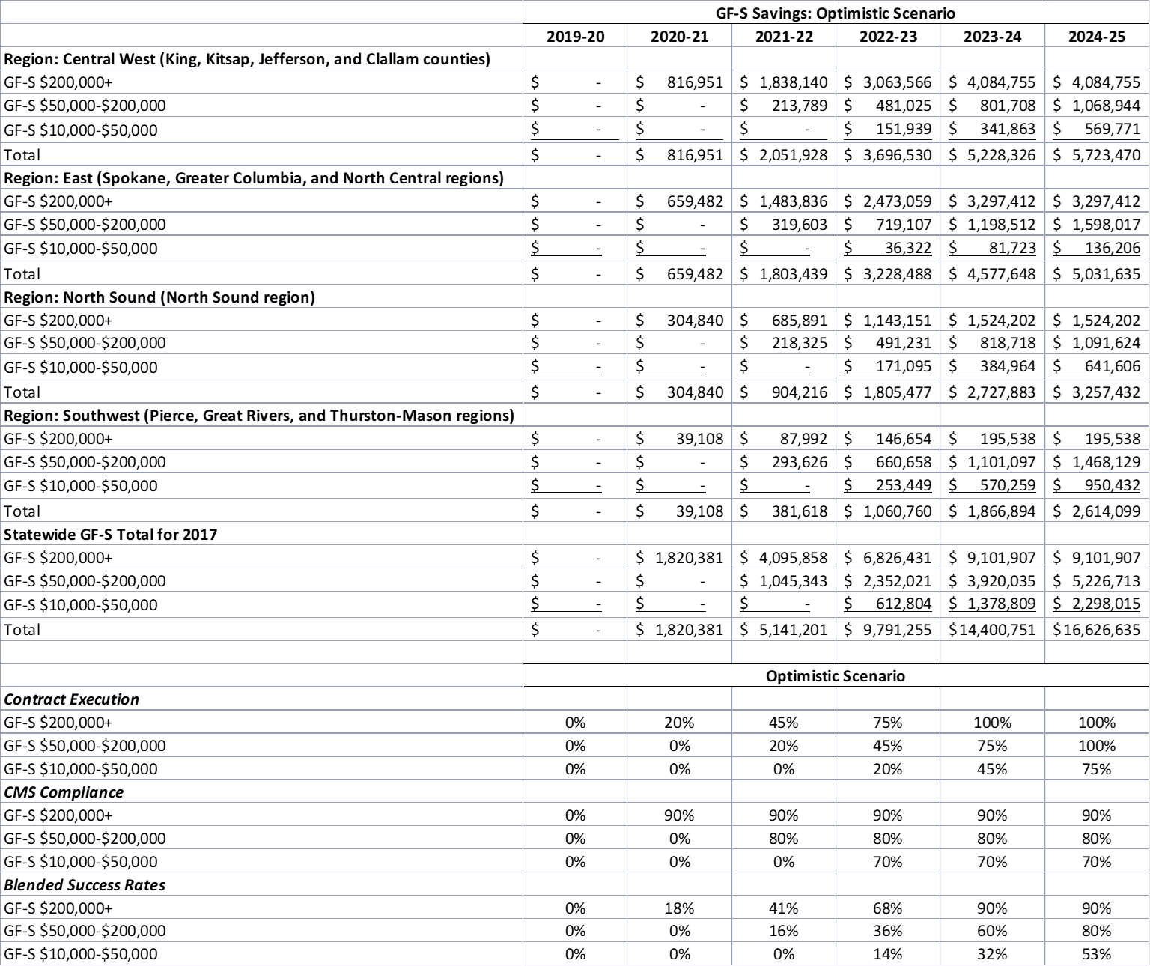

Table 3: Estimated Savings to State General Fund — Baseline Scenario
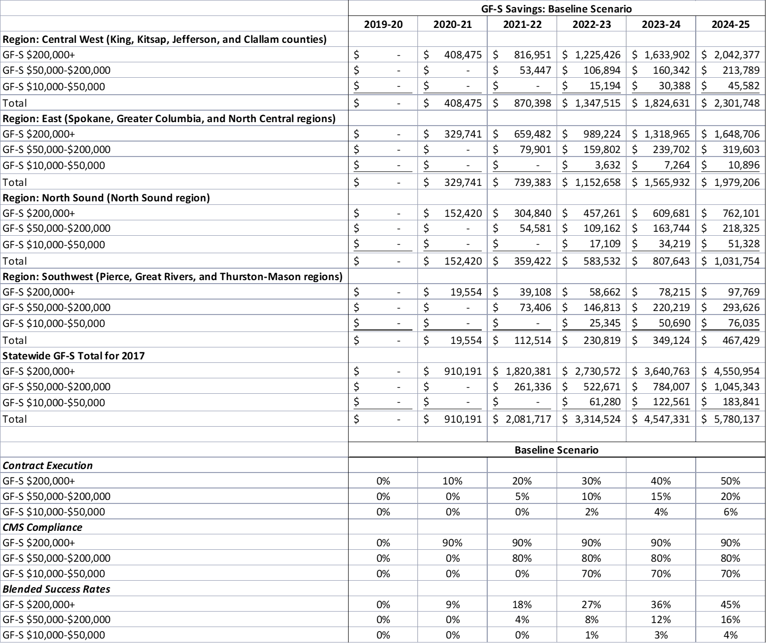

Table 4: Estimated Savings to State General Fund — Pessimistic Scenario
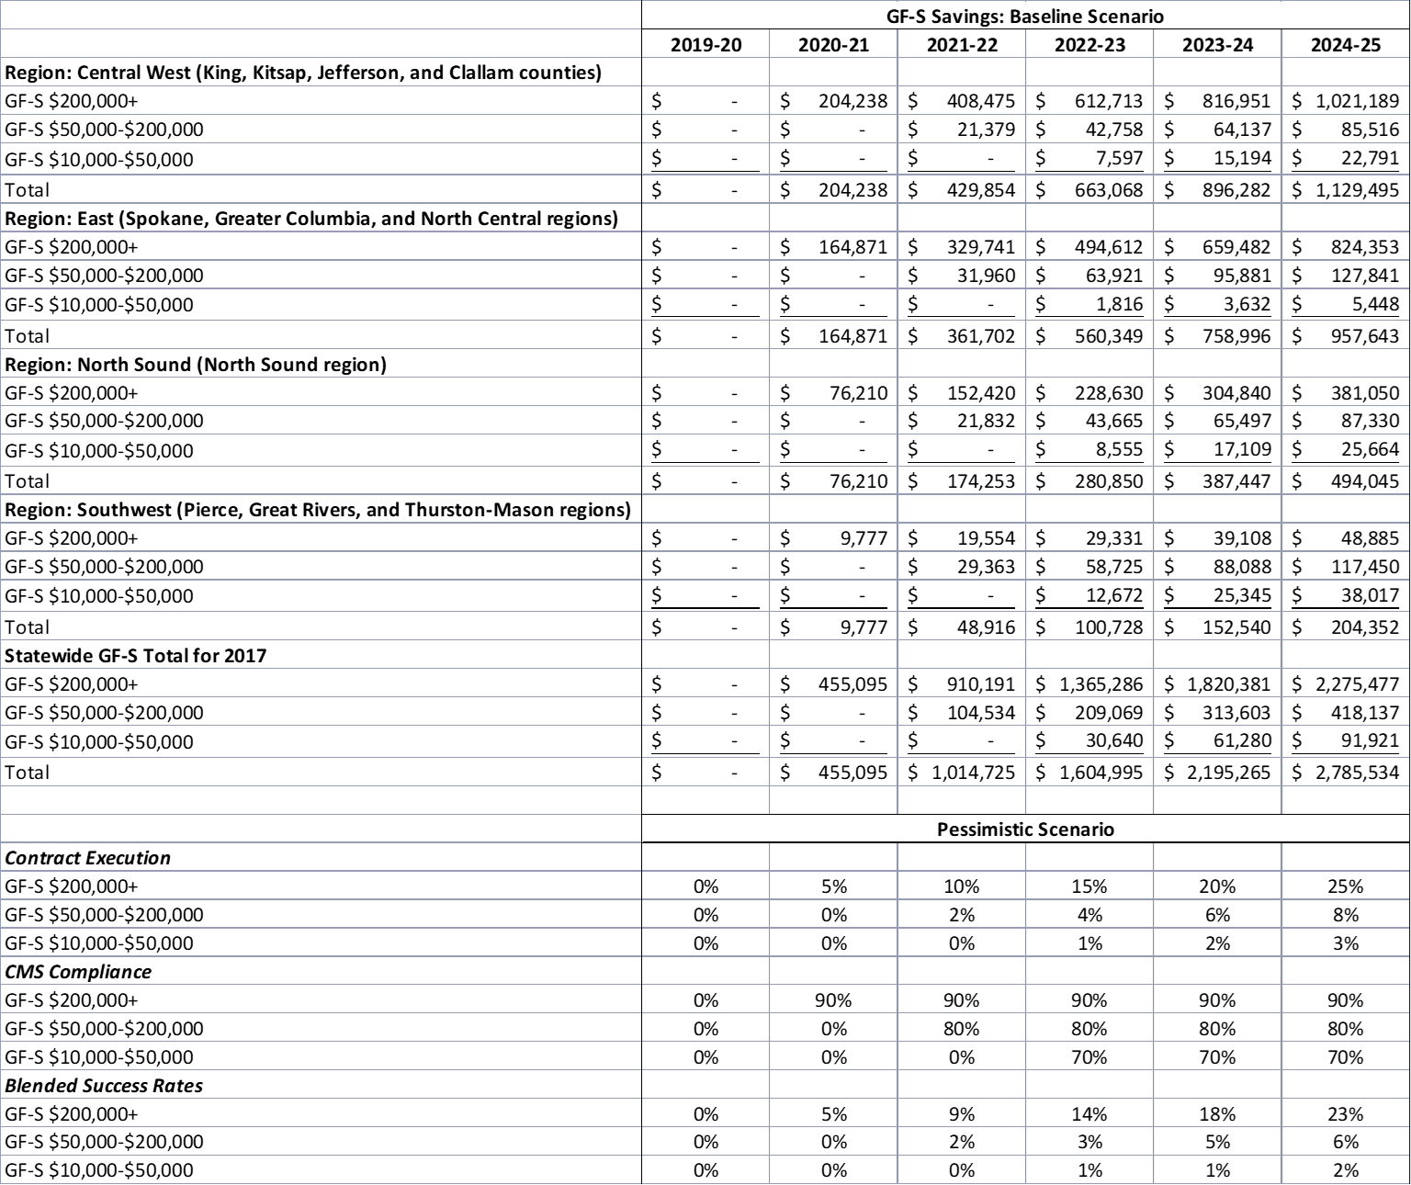

Appendix B: Proposed Legislation

Washington Indian Health Improvement Act

AN ACT Relating to establishing the governor’s Indian health advisory council and the Indian health improvement reinvestment account; reenacting and amending RCW 43.84.092; and adding a new chapter to Title 43 RCW.

BE IT ENACTED BY THE LEGISLATURE OF THE STATE OF WASHINGTON:

NEW SECTION. Sec. 1. (1) The legislature finds that:

As set forth in 25 U.S.C. Sec. 1602, it is the policy of the nation, in fulfillment of its special trust responsibilities and legal obligations to American Indians and Alaska Natives, to:

Ensure the highest possible health status for American Indians and Alaska Natives and to provide all resources necessary to effect that policy;

Raise the health status of American Indians and Alaska Natives to at least the levels set forth in the goals contained within the Healthy People 2020 initiative or successor objectives; and

Ensure tribal self-determination and maximum participation by American Indians and Alaska Natives in the direction of health care services so as to render the persons administering such services and the services themselves more responsive to the needs and desires of tribes and American Indian and Alaska Native communities;

According to the northwest tribal epidemiology center and the department of health, American Indians and Alaska Natives in the state experience some of the greatest health disparities compared to other groups, including excessively high rates of:

Premature mortality due to suicide, overdose, unintentional injury, and various chronic diseases; and

Asthma, coronary heart disease, hypertension, diabetes, pre-diabetes, obesity, dental caries, poor mental health, youth

depressive feelings, cigarette smoking and vaping, and cannabis use;

These health disparities are a direct result of both historical trauma, leading to adverse childhood experiences across multiple generations, and inadequate levels of federal funding to the Indian health service;

Under a 2016 update in payment policy from the centers for medicare and medicaid services, the state has the opportunity to shift more of the cost of care for American Indian and Alaska Native medicaid enrollees from the state general fund to the federal government if all of the federal requirements are met;

Because the federal requirements to achieve this cost shift and obtain the new federal funds place significant administrative burdens on Indian health service and tribal health facilities, the state has no way to shift these costs of care to the federal government unless the state provides incentives for tribes to take on these administrative burdens; and

The federal government’s intent for this update in payment policy is to help states, the Indian health service, and tribes to improve delivery systems for American Indians and Alaska Natives by increasing access to care, strengthening continuity of care, and improving population health.

(2) The legislature, therefore, intends to:

Establish that it is the policy of this state and the intent of this chapter, in fulfillment of the state's unique relationships and shared respect between sovereign governments, to:

Recognize the United States' special trust responsibility to provide quality health care and allied health services to American Indians and Alaska Natives, including those individuals who are residents of this state; and

Implement the national policies of Indian self- determination and achieving the highest possible health status for American Indians and Alaska Natives in the state; and

to:

Establish the governor’s Indian health advisory council

Adopt a biennial Indian health improvement advisory plan,

developed by the reinvestment committee;

Address issues with tribal implications that are not able to be resolved at the agency level; and

Provide oversight of the Indian health improvement reinvestment account;

Adopt a biennial Indian health improvement advisory plan;

Establish the Indian health improvement reinvestment account in order to provide incentives for tribes to assume the administrative burdens created by the federal requirements for the state to shift health care costs to the federal government;

Appropriate and deposit into the account all of the new state savings, subject to federal appropriations and less agreed upon administrative costs to maintain fiscal neutrality to the state general fund; and

Require the funds in the Indian health improvement reinvestment account to be spent only on costs for projects, programs, or activities identified in the Indian health improvement advisory plan.

NEW SECTION. Sec. 2. The definitions in this section apply throughout this chapter unless the context clearly requires otherwise.

“Advisory council” means the governor’s Indian health advisory council established in section 3 of this chapter.

“Advisory plan” means the plan described section 4 of this chapter.

"American Indian" or "Alaska Native" means any individual who is: (a) A member of a federally recognized tribe; or (b) eligible for the Indian health service.

"Authority" means the health care authority.

“Board” means the northwest Portland area Indian health board, an Oregon nonprofit corporation wholly controlled by the tribes in the states of Idaho, Oregon, and Washington.

“Commission” means the American Indian health commission for Washington state, a Washington nonprofit corporation wholly controlled by the tribes and urban Indian organizations in the state.

"Community health aide" means a tribal community health provider certified by a community health aide program of the Indian health service or one or more tribes or tribal organizations consistent with the provisions of 25 U.S.C. Sec. 1616l, who can perform a wide range of duties within the provider's scope of certified practice in health programs of a tribe, tribal organization, Indian health service facility, or urban Indian organization to improve access to culturally appropriate, quality care for American Indians and Alaska Natives and their families and communities, including but not limited to community health aides, community health practitioners, behavioral health aides, behavioral health practitioners, dental health aides, and dental health aide therapists.

“Community health aide program” means a community health aide certification board for the state consistent with 25 U.S.C. Sec. 1616l and the training programs and certification requirements established thereunder.

"Fee-for-service" means the state's medicaid program for which payments are made under the state plan, without a managed care entity, in accordance with the fee-for-service payment methodology.

"Indian health care provider" means a health care program operated by the Indian health service or by a tribe, tribal organization, or urban Indian organization as those terms are defined in 25 U.S.C. Sec. 1603.

"Indian health service" means the federal agency within the United States department of health and human services.

“New state savings” means the savings to the state general fund that are achieved as a result of the centers for medicare and medicaid services state health official letter 16- 002 and related guidance, calculated as the difference between (a) medicaid payments received from the centers for medicare and medicaid services based on the 100 percent federal medical assistance percentage; and (b) medicaid payments received from the centers for medicare and medicaid services based on the federal medical assistance percentage that would apply in the absence of state health official letter 16-002 and related guidance.

“Reinvestment account” means the Indian health improvement reinvestment account established in section 4(1) of this chapter.

“Reinvestment committee” means the Indian health improvement reinvestment committee established in section 3(3) of this chapter.

"Tribal organization" has the meaning set forth in 25

U.S.C. Sec. 5304.

“Tribally operated facility” means a health care facility operated by one or more tribes or tribal organizations to provide specialty services, including but not limited to evaluation and treatment services, secure detox services, inpatient psychiatric services, nursing home services, and residential substance use disorder services.

"Tribe" means any Indian tribe, band, nation, or other organized group or community, including any Alaska Native village or group or regional or village corporation as defined in or established pursuant to the Alaska Native claims settlement act (43 U.S.C. Sec. 1601 et seq.) which is recognized as eligible for the special programs and services provided by the United States to Indians because of their status as Indians.

"Urban Indian" means any individual who resides in an urban center and is: (a) a member of a tribe terminated since 1940 and those tribes recognized now or in the future by the state in which they reside, or who is a descendant, in the first or second

degree, of any such member; (b) an Eskimo or Aleut or other Alaska Native;(c) considered by the secretary of the interior to be an Indian for any purpose; or (d) considered by the United States secretary of health and human services to be an Indian for purposes of eligibility for Indian health services, including as a California Indian, Eskimo, Aleut, or other Alaska Native.

"Urban Indian organization" means an urban Indian organization, as defined by 25 U.S.C. Sec. 1603(29).

NEW SECTION. Sec. 3. (1) The governor's Indian health advisory council is established, consisting of:

The following voting members:

One representative from each tribe, designated by the tribal council, who is either the tribe's commission delegate or an individual specifically designated for this role, or his or her designee;

The chief executive officer of each urban Indian organization, or the urban Indian organization’s commission delegate if applicable, or his or her designee;(iii) One member from each of the two largest caucuses of the house of representatives, appointed by the speaker of the house of representatives;

One member from each of the two largest caucuses of the senate, appointed by the president of the senate; and

One member representing the governor's office; and

The following non-voting members:

One member of the executive leadership team from each of the following state agencies: The authority; the department of children, youth, and families; the department of commerce; the department of corrections; the department of health; the department of social and health services; the office of the insurance commissioner; the office of the superintendent of public instruction; and the Washington health benefit exchange;

The chief operating officer of each Indian health service area office and service unit, or his or her designee;

The executive director of the commission, or his or her designee; and

The executive director of the board, or his or her designee.

The advisory council will meet at least three times per year when the legislature is not in session, in a forum that offers both in-person and remote participation where everyone can hear and be heard.

The advisory council will have the responsibility to:

Adopt the biennial Indian health improvement advisory plan prepared and amended by the reinvestment committee as described in section 4 no later than November 1st of each odd- numbered year;

Address current or proposed policies or actions that have tribal implications and are not able to be resolved or addressed at the agency level;

Facilitate better understanding among advisory council members and their support staff of the Indian health system, American Indian and Alaska Native health disparities and historical trauma, and tribal sovereignty and self-governance;

Provide oversight of contracting and performance of service coordination organizations or service contracting entities as defined in RCW 70.320.010 in order to address their impacts on services to American Indians and Alaska Natives and relationships with Indian health care providers; and

Provide oversight of the Indian health improvement reinvestment account established in section 5 of this chapter, ensuring that amounts expended from the reinvestment account are consistent with the advisory plan adopted under section 4 of this chapter.

The reinvestment committee of the advisory council is established, consisting of the following members of the advisory council:

With voting rights on the reinvestment committee, every advisory council member who represents a tribe or an urban Indian organization; and

With non-voting rights on the reinvestment committee, every advisory council member who represents a state agency, the Indian health service area office or a service unit, the commission, and the board.

The advisory council may appoint technical advisory committees, which may include members of the advisory council, as needed to address specific issues and concerns.

The authority, in conjunction with the represented state agencies on the advisory council, shall supply such information and assistance as are deemed necessary for the advisory council and its committees to carry out its duties under this section.

The authority shall provide (a) administrative and clerical assistance to the advisory council and its committees and

(b) technical assistance with the assistance of the commission.

The advisory council meetings, reports and recommendations, and other forms of collaboration described in this chapter support the tribal consultation process but are not a substitute for the requirements for state agencies to conduct consultation or maintain government-to-government relationships with tribes under federal and state law.

NEW SECTION. Sec. 4. (1) With assistance from the authority, the commission, and other member entities of the advisory council, the reinvestment committee of the advisory council will prepare and amend from time to time a biennial Indian health improvement advisory plan to:

Raise the health status of American Indians and Alaska Natives in the state to at least the levels set forth in the goals contained in the federal healthy people 2020 initiative or successor objectives; or

Help the state, the Indian health service, tribes, and urban Indian organizations, statewide or in regions, improve

delivery systems for American Indians and Alaska Natives by increasing access to care, strengthening continuity of care, and improving population health through investments in capacity and infrastructure.

(2) The advisory plan will include the following:

An assessment of Indian health and Indian health care in the state; and

Specific recommendations for programs, projects, or activities, along with recommended reinvestment account expenditure amounts and priorities for expenditures, for the next two state fiscal bienniums. The programs, projects, and activities may include but are not limited to:

Tribally operated facilities providing evaluation, treatment, and recovery services for opioid use disorder, other substance use disorders, mental illness, or specialty care;

Increased access to quality, culturally appropriate, trauma-informed specialty services, including adult and pediatric psychiatric services, medication consultation, and addiction or geriatric psychiatry;

A third-party administrative entity to provide, arrange, and make payment for services for American Indians and Alaska Natives;

Expansion of suicide prevention services, including culture-based programming, to instill and fortify cultural practices as a protective factor;

Expansion of traditional healing services;

Development of a community health aide program, including a community health aide certification board for the state consistent with 25 U.S.C. Sec. 1616l, and support for community health aide services;

Health information technology capability within tribes and urban Indian organizations to assure the technological capacity to: (A) Produce sound evidence for Indian health care provider best practices; (B) effectively coordinate care between Indian health care providers and non-Indian health care providers;

provide interoperability with state claims and reportable data systems, such as for immunizations and reportable conditions; and

support patient-centered medical home models, including sufficient resources to purchase and implement certified electronic health record systems, such as hardware, software, training, and staffing;

Support for care coordination by tribes and other Indian Health Care Providers to mitigate barriers to access to care for American Indians and Alaska Natives, with duties to include without limitation: (A)Follow-up of referred appointments;

(B) routine follow-up care for management of chronic disease; (C) transportation; and (D) increasing patient understanding of provider instructions;

Expanded support for tribal and urban Indian epidemiology centers to create a system of epidemiological analysis that meets the needs of the state's American Indian and Alaska Native population; and

Other health care services and public health services that contribute to reducing health inequities for American Indians and Alaska Natives in the state and increasing access to quality, culturally appropriate health care for American Indians and Alaska Natives in the state; and

Review of how programs, projects, or activities that have received investments from the reinvestment account have or have not achieved the objectives and why.

NEW SECTION. Sec. 5. (1) There shall be a fund in the state treasury known as the Indian health improvement reinvestment account, which shall consist of all moneys appropriated and deposited under this chapter and any moneys appropriated to it by law. In order to maintain effective expenditure and revenue control, the reinvestment account is subject in all respects to chapter 43.88 RCW.

Moneys in the reinvestment account may not be expended for any purpose other than projects, programs, or activities identified in section 4.

Beginning July 1, 2019, the new state savings as defined in section 2(11) of this chapter, less the state’s administrative costs as agreed upon by the state and the reinvestment committee, are appropriated and directed for deposit into the reinvestment account. With advice from the advisory council, the authority will develop a report and methodology to identify and track the new state savings.

The authority will pursue new state savings for medicaid managed care premiums on an actuarial basis and in consultation with tribes.

NEW SECTION. Sec. 6. This chapter may be known and cited as the “Washington Indian health improvement act.”

Sec. 7. RCW 43.84.092 and 2017 3rd sp.s. c 25 s 50, 2017 3rd

sp.s. c 12 s 12, and 2017 c 290 s 8 are each reenacted and amended to read as follows:

All earnings of investments of surplus balances in the state treasury shall be deposited to the treasury income account, which account is hereby established in the state treasury.

The treasury income account shall be utilized to pay or receive funds associated with federal programs as required by the federal cash management improvement act of 1990. The treasury income account is subject in all respects to chapter 43.88 RCW, but no appropriation is required for refunds or allocations of interest earnings required by the cash management improvement act. Refunds of interest to the federal treasury required under the cash management improvement act fall under RCW 43.88.180 and shall not require appropriation. The office of financial management shall determine the amounts due to or from the federal government pursuant to the cash management improvement act. The office of financial management may direct transfers of funds between accounts as deemed necessary to implement the provisions of the

cash management improvement act, and this subsection. Refunds or allocations shall occur prior to the distributions of earnings set forth in subsection (4) of this section.

Except for the provisions of RCW 43.84.160, the treasury income account may be utilized for the payment of purchased banking services on behalf of treasury funds including, but not limited to, depository, safekeeping, and disbursement functions for the state treasury and affected state agencies. The treasury income account is subject in all respects to chapter 43.88 RCW, but no appropriation is required for payments to financial institutions. Payments shall occur prior to distribution of earnings set forth in subsection (4) of this section.

Monthly, the state treasurer shall distribute the earnings credited to the treasury income account. The state treasurer shall credit the general fund with all the earnings credited to the treasury income account except:

The following accounts and funds shall receive their proportionate share of earnings based upon each account's and fund's average daily balance for the period: The aeronautics account, the aircraft search and rescue account, the Alaskan Way viaduct replacement project account, the brownfield redevelopment trust fund account, the budget stabilization account, the capital vessel replacement account, the capitol building construction account, the Cedar River channel construction and operation account, the Central Washington University capital projects account, the charitable, educational, penal and reformatory institutions account, the Chehalis basin account, the cleanup settlement account, the Columbia river basin water supply development account, the Columbia river basin taxable bond water supply development account, the Columbia river basin water supply revenue recovery account, the common school construction fund, the community forest trust account, the connecting Washington account, the county arterial preservation account, the county criminal justice assistance account, the deferred compensation administrative account, the deferred compensation principal

account, the department of licensing services account, the department of retirement systems expense account, the developmental disabilities community trust account, the diesel idle reduction account, the drinking water assistance account, the drinking water assistance administrative account, the early learning facilities development account, the early learning facilities revolving account, the Eastern Washington University capital projects account, the Interstate 405 express toll lanes operations account, the education construction fund, the education legacy trust account, the election account, the electric vehicle charging infrastructure account, the energy freedom account, the energy recovery act account, the essential rail assistance account, The Evergreen State College capital projects account, the federal forest revolving account, the ferry bond retirement fund, the freight mobility investment account, the freight mobility multimodal account, the grade crossing protective fund, the public health services account, ((the high capacity transportation account,)) the state higher education construction account, the higher education construction account, the highway bond retirement fund, the highway infrastructure account, the highway safety fund, the high occupancy toll lanes operations account, the hospital safety net assessment fund, the Indian health improvement reinvestment account, the industrial insurance premium refund account, the judges' retirement account, the judicial retirement administrative account, the judicial retirement principal account, the local leasehold excise tax account, the local real estate excise tax account, the local sales and use tax account, the marine resources stewardship trust account, the medical aid account, the mobile home park relocation fund, the money-purchase retirement savings administrative account, the money-purchase retirement savings principal account, the motor vehicle fund, the motorcycle safety education account, the multimodal transportation account, the multiuse roadway safety account, the municipal criminal justice assistance account, the natural resources deposit account, the oyster reserve land

account, the pension funding stabilization account, the perpetual surveillance and maintenance account, the pollution liability insurance agency underground storage tank revolving account, the public employees' retirement system plan account, the public employees' retirement system combined plan and plan account, the public facilities construction loan revolving account beginning July 1, 2004, the public health supplemental account, the public works assistance account, the Puget Sound capital construction account, the Puget Sound ferry operations account, the Puget Sound taxpayer accountability account, the real estate appraiser commission account, the recreational vehicle account, the regional mobility grant program account, the resource management cost account, the rural arterial trust account, the rural mobility grant program account, the rural Washington loan fund, the sexual assault prevention and response account, the site closure account, the skilled nursing facility safety net trust fund, the small city pavement and sidewalk account, the special category C account, the special wildlife account, the state employees' insurance account, the state employees' insurance reserve account, the state investment board expense account, the state investment board commingled trust fund accounts, the state patrol highway account, the state route number 520 civil penalties account, the state route number 520 corridor account, the state wildlife account, the supplemental pension account, the Tacoma Narrows toll bridge account, the teachers' retirement system plan 1 account, the teachers' retirement system combined plan 2 and plan 3 account, the tobacco prevention and control account, the tobacco settlement account, the toll facility bond retirement account, the transportation 2003 account (nickel account), the transportation equipment fund, the transportation future funding program account, the transportation improvement account, the transportation improvement board bond retirement account, the transportation infrastructure account, the transportation partnership account, the traumatic brain injury account, the tuition recovery trust fund, the University of Washington bond retirement fund, the

University of Washington building account, the volunteer firefighters' and reserve officers' relief and pension principal fund, the volunteer firefighters' and reserve officers' administrative fund, the Washington judicial retirement system account, the Washington law enforcement officers' and firefighters' system plan 1 retirement account, the Washington law enforcement officers' and firefighters' system plan 2 retirement account, the Washington public safety employees' plan 2 retirement account, the Washington school employees' retirement system combined plan 2 and 3 account, the Washington state health insurance pool account, the Washington state patrol retirement account, the Washington State University building account, the Washington State University bond retirement fund, the water pollution control revolving administration account, the water pollution control revolving fund, the Western Washington University capital projects account, the Yakima integrated plan implementation account, the Yakima integrated plan implementation revenue recovery account, and the Yakima integrated plan implementation taxable bond account. Earnings derived from investing balances of the agricultural permanent fund, the normal school permanent fund, the permanent common school fund, the scientific permanent fund, the state university permanent fund, and the state reclamation revolving account shall be allocated to their respective beneficiary accounts.

Any state agency that has independent authority over accounts or funds not statutorily required to be held in the state treasury that deposits funds into a fund or account in the state treasury pursuant to an agreement with the office of the state treasurer shall receive its proportionate share of earnings based upon each account's or fund's average daily balance for the period.

In conformance with Article II, section 37 of the state Constitution, no treasury accounts or funds shall be allocated earnings without the specific affirmative directive of this section.

--- END ---

